NINGBO AMERITEK ELECTRIC Co.,Ltd
ADD: NO.27,North Huanzhen Road,Ditang Town,Yuyao City, Ningbo,China 315490
TEL: 0086-574-62263484 FAX:0086-574-62264199 Email:Rebecca413@263.net

GAS LIGHTER LIST

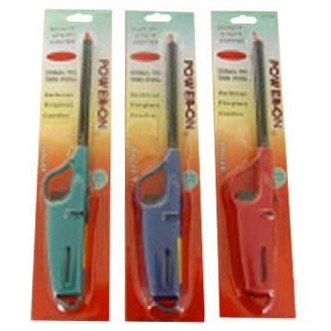 | Products Name: Gas Lighter Mould Number:AMK-002B  Place of Origin: China Brand Name: Buyer’s Label  Price Terms:FOB,CNF Minimum Order:6,000pcs  Payment Terms: T/T Delivery Lead Time:30Days  Pacing:1pc/double Blister Card inside,144pcs/Ctn Meas:52x32.8x32cm  N.W:10kg G.W:13kg have got CPSC in USA.(children resistant)  Conveyance:20’FLC 79,200pcs FOB Ningbo Price: USD0.255/PC
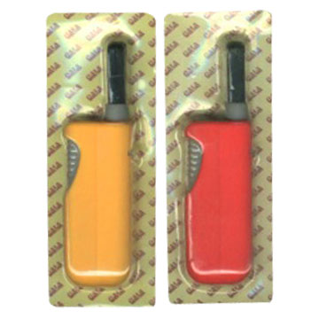 | Products Name: Gas Lighter Mould Number:AMK-001  Place of Origin: China Brand Name: Buyer’s Label  Price Terms: FOB,CNF Minimum Order:12,000pcs  Payment Terms: T/T Delivery Lead Time:25-30Days  Supply Ability:5*20FCL/month Meas:35x29x25.5cm  Pacing:1pc/double Blister Card inside,240pcs/Ctn  Conveyance:20’FLC 276,000pcs FOB Ningbo Price: USD0.16/PC
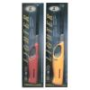 | Products Name: Gas Lighter Mould Number:AMK-003B  Place of Origin: China Brand Name: Buyer’s Label  Price Terms:FOB,CNF Minimum Order:6,000pcs  Payment Terms: T/T Delivery Lead Time:30Days  Pacing:1pc/double Blister Card inside,120pcs/Ctn Meas:47.5x34x24cm  Conveyance:20’FLC 92,400pcs FOB Ningbo Price: USD0.25/PC
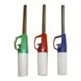 | Products Name: BBQ Lighter Mould Number:AMK-007  Place of Origin: China Brand Name: Buyer’s Label  Price Terms:FOB,CNF Minimum Order:6,000pcs  Payment Terms: T/T Delivery Lead Time:30Days  Pacing:1pc/double Blister Card inside,144pcs/Ctn  N.W:8.5kg G.W:11kg Meas:45x28x30cm  Conveyance:20’FLC 90,000pcs FOB Ningbo Price: USD0.20/PC
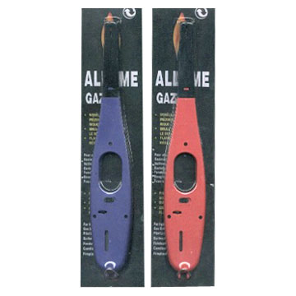 | Products Name: Gas Lighter Mould Number:XAMK-014  Place of Origin: China Brand Name: Buyer’s Label  Price Terms:FOB,CNF Minimum Order:6,000pcs  Payment Terms: T/T Delivery Lead Time:30Days  Pacing:1pc/double Blister Card inside,120pcs/Ctn  N.W:9kg G.W:13kg Meas:46x35x20cm  Conveyance:20’FLC 108,000pcs FOB Ningbo Price:USD0.195/PC
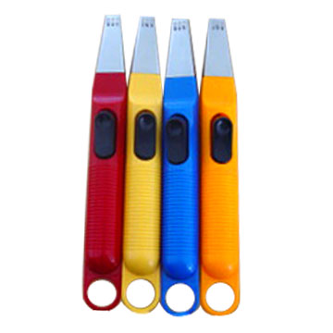 | Products Name: Spark Lighter Mould Number:AMK-016  Place of Origin: China Brand Name: Buyer’s Label  Price Terms:FOB,CNF Minimum Order:6,000pcs  Payment Terms: T/T Delivery Lead Time:30Days  Pacing:1pc/double Blister Card inside,120pcs/Ctn  N.W:8.5kg G.W:11kg Meas:62x32.5x25cm  Conveyance:20’FLC 66,000pcs FOB Ningbo Price: USD0.20/PC
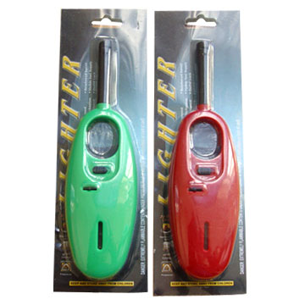 | Products Name: Gas Lighter Mould Number:AMK-700  Place of Origin: China Brand Name: Buyer’s Label  Price Terms:FOB,CNF Minimum Order:120,000pcs  Payment Terms: T/T Delivery Lead Time:30Days  Pacing:1pc/double Blister Card inside,240pcs/Ctn  N.W:11kg G.W:13kg Meas:55x40x24cm  Conveyance:20’FLC 129,600pcs FOB Ningbo Price: USD0.18/PC
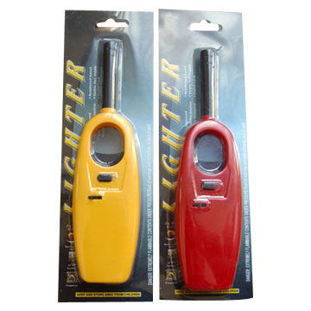 | Products Name: Gas Lighter Mould Number:XAMK-500  Place of Origin: China Brand Name: Buyer’s Label  Price Terms:FOB,CNF Minimum Order:120,000pcs  Payment Terms: T/T Delivery Lead Time:30Days  Pacing:1pc/double Blister Card inside,240pcs/Ctn  N.W:11kg G.W:13kg Meas:55x40x20cm  Conveyance:20’FLC 156,000pcs FOB Ningbo Price:USD0.17/PC
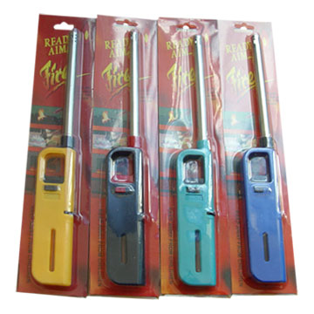 | Products Name: Gas Lighter Mould Number:AMK-20  Place of Origin: China Brand Name: Buyer’s Label  Price Terms:FOB,CNF Minimum Order:6,000pcs  Payment Terms: T/T Delivery Lead Time:25-30Days  Pacing:1pc/double Blister Card inside,120pcs/Ctn  N.W:8.5kg G.W:11kg Meas:41x32.5x21.5cm  Conveyance:20’FLC 126,000pcs FOB Ningbo Price: USD0.18/PC
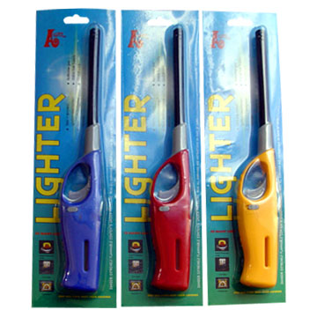 | Products Name: Gas Lighter Mould Number:AMK-003  Place of Origin: China Brand Name: Buyer’s Label  Price Terms:FOB,CNF Minimum Order:120,000pcs  Payment Terms: T/T Delivery Lead Time:25-30Days  Pacing:1pc/double Blister Card inside,240pcs/Ctn  N.W:11kg G.W:13kg Meas:47.5x34x24cm  Conveyance:20’FLC 92,400pcs FOB Ningbo Price: USD0.24/pc
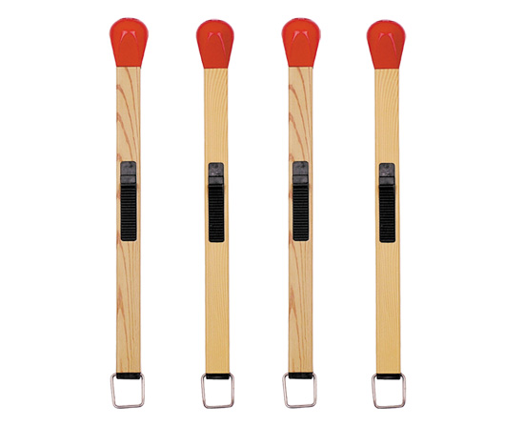 | Products Name: Match Lighter Mould Number:AMK-02A  Place of Origin: China Brand Name: Buyer’s Label  Price Terms:FOB,CNF Minimum Order:120,000pcs  Payment Terms: T/T Delivery Lead Time:25-30Days  FOB Ningbo price is USD0.25/PC  500pcs/ctn 50pcs/display box Ctn size:65x50x21cm
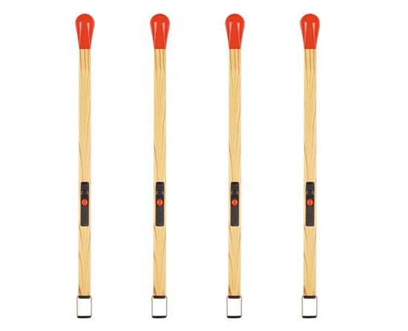 | AMK-161 FOB Ningbo price is USD0.70/PC (USA)  240pcs/ctn 24pcs/display box Ctn size:70x43x40cm
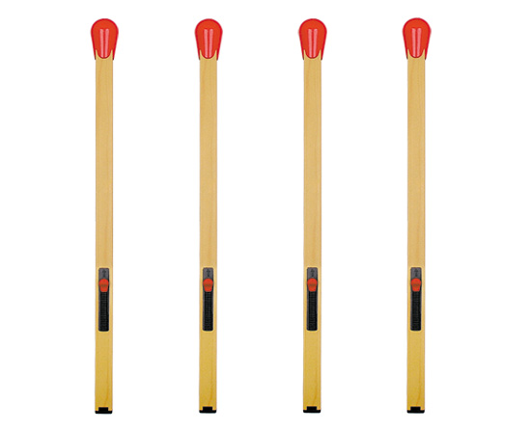 | AMK-162 FOB Ningbo price is USD0.72/PC  200pcs/ctn 25pcs/display box Ctn size:68x35x39cm
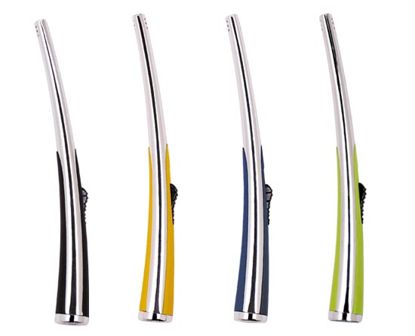 | AMK-1001 FOB Ningbo price is USD0.80/PC  240pcs/ctn 30pcs/display box Ctn size:75x39x23cm
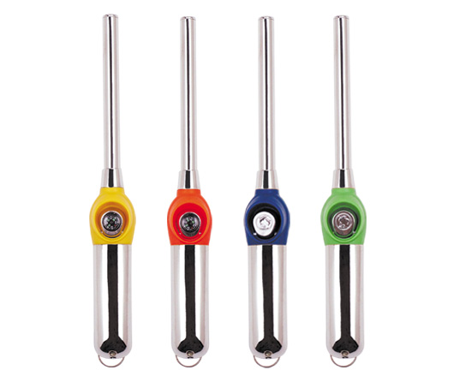 | AMK-1008 FOB Ningbo price is USD0.72/PC  300pcs/ctn 50pcs/display box Ctn size:75.5x53x25.5cm
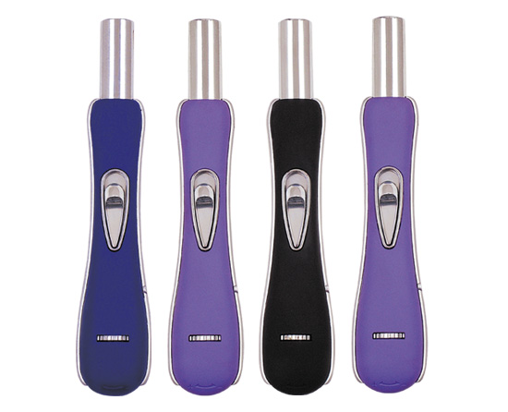 | AMK-1010 FOB Ningbo price is USD0.73/PC  240pcs/ctn 24 pcs/display box Ctn size:70x48x22cm
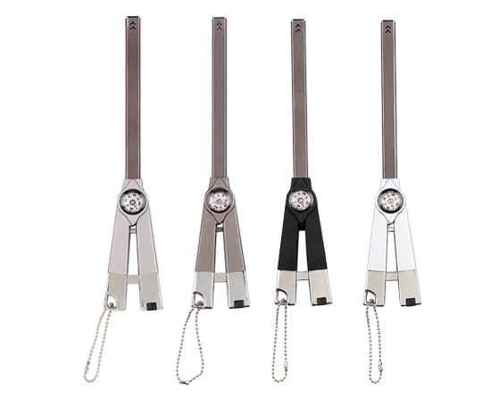 | AMK-1023 FOB Ningbo price is USD0.76/PC  240pcs/ctn 40pcs/display box Ctn size:50x43x28cm
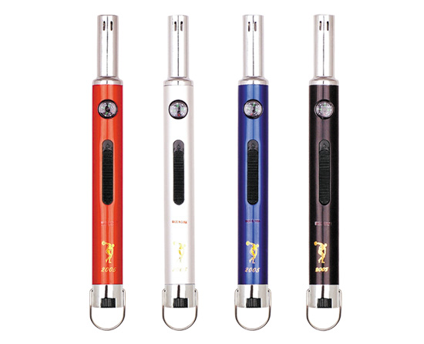 | AMK-123 FOB Ningbo price is USD0.40/PC  500pcs/ctn 50pcs/display box Ctn size:53x43x25cm
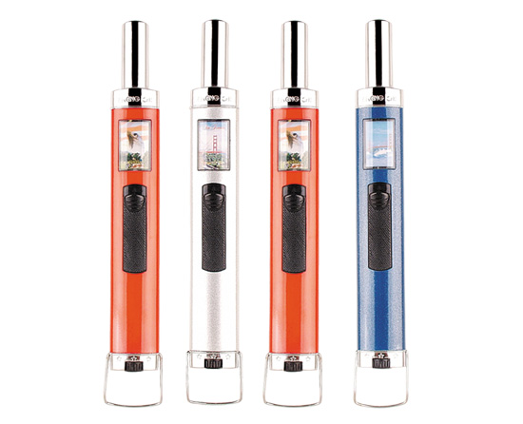 | AMK-129 FOB Ningbo price is USD  500pcs/ctn 50pcs/display box Ctn size:65x50x47cm

. MS Rebecca
Ningbo Ameritek Electric Co.,Ltd
Tel:86-574-62263484
Fax:86-574-6226419
Mo:86-13336874519
MSN:Rebecca_ruan@hotmail.com

